Carers Services
Warwickshire Carer Wellbeing Service offers support to carers across the county in person, over the phone or online. Do you know someone who could benefit from a little support? #Carers warwickshire.gov.uk/carers #BestWarwickshire
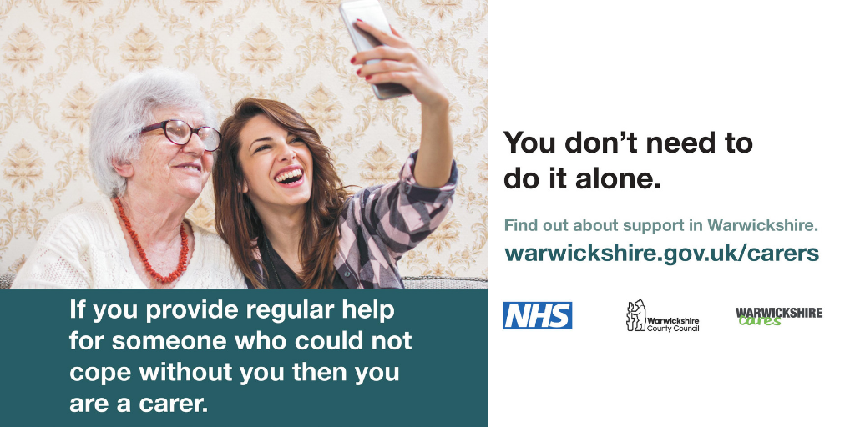

Did you know there's a free, tailored service available for #Carers in #Warwickshire to access support? If you look after someone, the Carers Wellbeing Service is here for you - in person, over the phone or online warwickshire.gov.uk/carers #BestWarwickshire
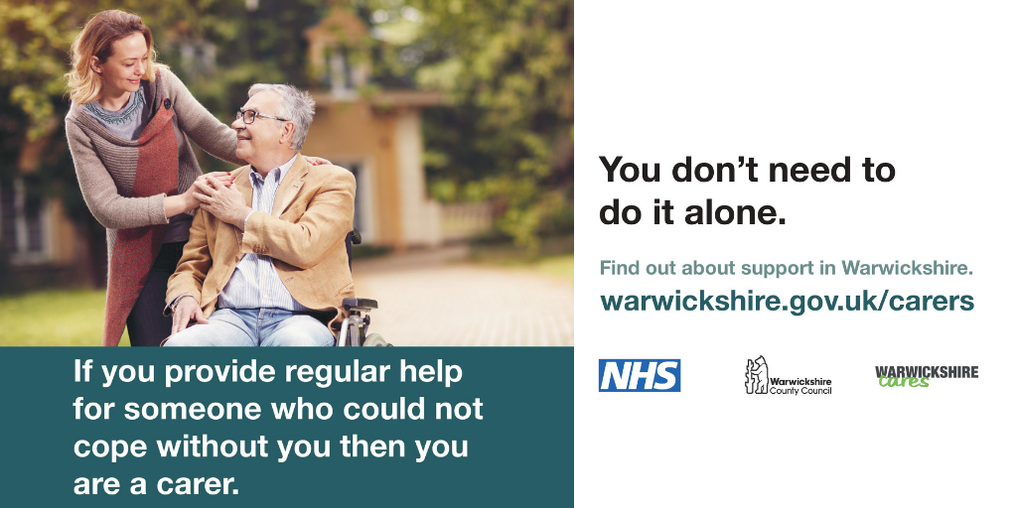

Did you know there's a free, tailored service available for #Carers in #Warwickshire to access support? If you look after someone, the Carers Wellbeing Service is here for you - in person, over the phone or online warwickshire.gov.uk/carers #BestWarwickshire
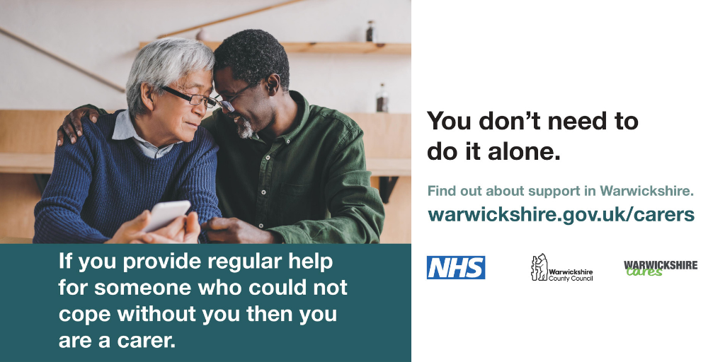

Are you a carer? Get personalised support face to face, by phone or using Skype with our Carers Wellbeing Service warwickshire.gov.uk/carers #BestWarwickshire

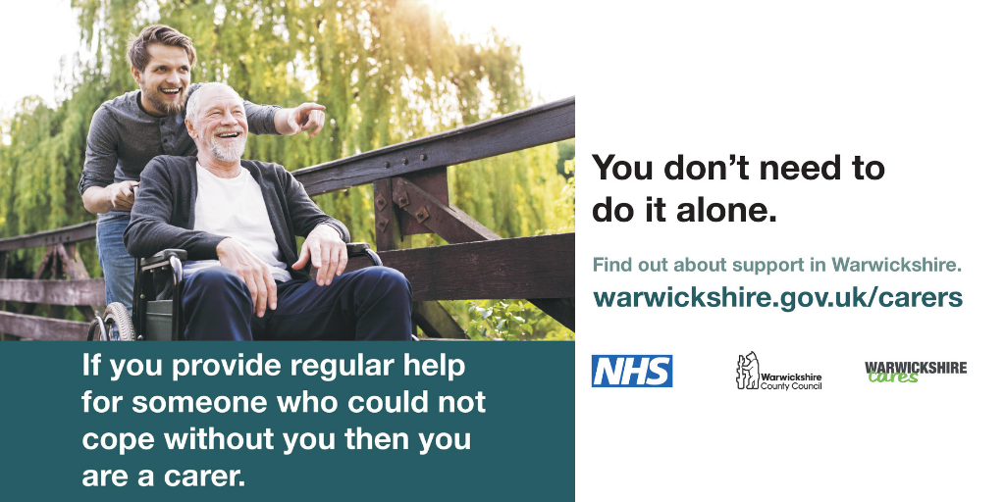

Warwickshire County Council provides a range of services to help unpaid carers access the support they deserve. Read more here: warwickshire.gov.uk/carers #BestWarwickshire

