Dunchurch GP Surgery – Coronavirus Update Information

In keeping with government guidelines, the surgery has moved to a “telephone triage first” system to avoid patients having to come in for unnecessary contact.

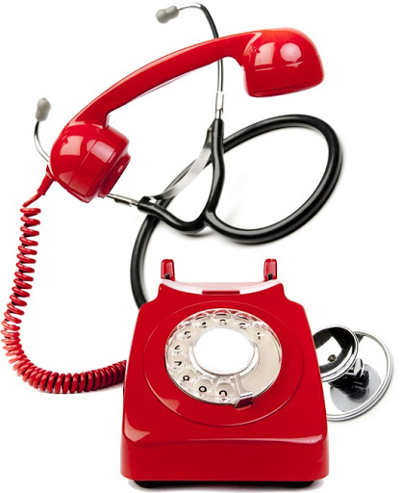
This has been very successful and convenient for many patients, however, not all medical problems can be diagnosed or treated safely without an examination.

We would like to reassure all patients who need to use the surgery that you can be seen safely for face-to-face appointments if your doctor suggests this is required.

Don’t let coronavirus stop you from seeking timely medical advice - If you have worrying or persistent symptoms, we are here to help. Appointment via reception on 01788 522448.

